

A service agreement is a document.



This is an agreement between you and Senses Australia.



The service agreement says you would like Senses Australia to give you services.



Your NDIS plan says the goals you would like to work on. The services are things that help you reach the goals on your plan.



When you and Senses Australia agree, we both sign the service agreement.

**What is expected of you?**



You choose Senses Australia as your service provider. This means you want Senses Australia to give you some or all of the services on your plan.

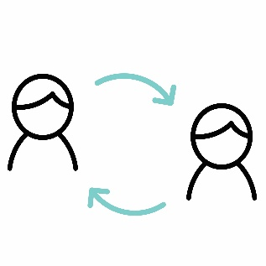

You and Senses Australia will work together.



It is helpful for Senses Australia to have a copy of your plan. If you are happy with this, please provide Senses Australia with a copy of your plan. If your plan changes, please tell Senses Australia.



Senses Australia will charge for the services. See “Appendix 1 – service plan” for the amounts charged.



If the amount of money in your plan changes, tell Senses Australia.



Senses Australia might ask you to pay for services if there is no money left on your plan.



If you need to cancel or change the service you need to tell us 2 days before hand, during regular business hours. For example, if your appointment is at 1pm on Monday, you need to let us know by 1pm on the Thursday before.



If you do not cancel a service by 2days before the service is meant to occur, Senses Australia can ask you to pay for this.



Tell Senses Australia if you are not happy with the services.



Tell Senses Australia 30 days ahead of time if you don’t want to keep receiving services from Senses Australia.

**What is expected of Senses Australia?**



We give you information in a way that you would like.

We keep information about you. We need information to help us provide a good service.



We work together with you.



We ask you how you want services to be provided.



We treat you with courtesy and respect.

We communicate openly and honestly in a good amount of time.



Senses Australia will tell you if the money is almost used up.

**The Service agreement says:**

What services you will receive

How much the services cost

Who pays for the services



More information can be found on our website: **ww.senses.org.au**

If you have any questions, please contact Senses Australia:



Telephone on 1300 111 881



Send us an e-mail – [admingroup@senses.org.au](mailto:admingroup@senses.org.au)



Send a letter to the CEO, Senses Australia’s

PO Box 143,

Burswood, WA, 6100



In person to any Senses Australia employee or volunteer